Assignment MySQL

-By Anamika

**Table 1: SalesPeople**

**Snum**is Primary key

**Sname**is Unique constraint

**Snum Sname City Comm**

**1001** Peel. London .12

1002 Serres Sanjose .13

1004 Motika London .11

1007 Rifkin Barcelona .15

1003 Axelrod Newyork .10

Syntax:

CREATE TABLE salespeople (

Snum INT PRIMARY KEY,

Sname VARCHAR(30) UNIQUE ,

City VARCHAR(30),

Comm INT

);

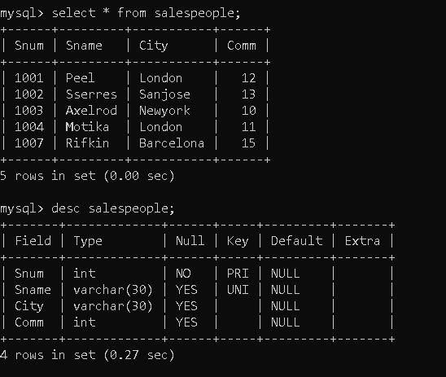

**Table 2: Customers**

**Cnum**is Primary Key

**City**has not null constraint .

**Snum**is foreign key constraint refers Snum column of SalesPeople table.

**Cnum** **Cname City Snum**

2001 Hoffman London 1001

2002 Giovanni Rome 1003

2003 Liu Sanjose 1002

2004 Grass Berlin 1002

2006 Clemens London 1001

2008 Cisneros Sanjose 1007

2007 Pereira Rome 1004

Syntax:

Create Table Customers(Cnum INT PRIMAY KEY,

Cname VARCHAR(30),

City VARCHAR(30) NOT NULL,

Snum INT,

FOREIGN KEY (Snum) REFERENCES Salespeople(Snum)

);

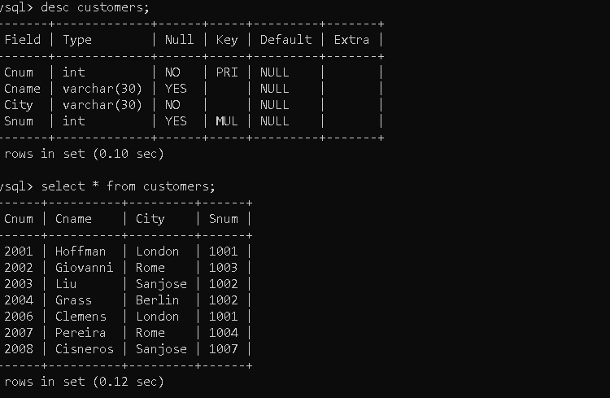

**Table 3: Orders**

**Onum**is Primary key

**Cnum**is foreign key refers to Cnum column of Customers table. **Snum**is foreign key refers Snum column of SalesPeople table.

**Onum Amt Odate Cnum Snum**

3001 18.69 3-10-1990 2008 1007

3003 767.19 3-10-1990 2001 1001

3002 1900.10 3-10-1990 2007 1004

3005 5160.45 3-10-1990 2003 1002

3006 1098.16 3-10-1990 2008 1007

3009 1713.23 4-10-1990 2002 1003

3007 75.75 4-10-1990 2004 1002

3008 4273.00 5-10-1990 2006 1001

3010 1309.95 6-10-1990 2004 1002

3011 9891.88 6-10-1990 2006 1001

Syntax:

CREATE TABLE orders (

Onum INT PRIMARY KEY,

Amt decimal(6,2),

Odate VARCHAR(10) NOT NULL,

Cnum INT NOT NULL,

Snum INT NOT NULL,

FOREIGN KEY (Cnum) REFERENCES Customers(Cnum),

FOREIGN KEY (Snum) REFERENCES Salespeople(Snum)

);

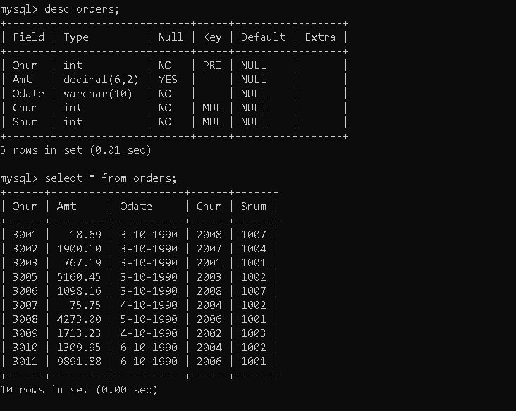

On the basis of above tables perform given below questions

1. Count the number of Salesperson whose name begin with **‘a’**/**’A’**.

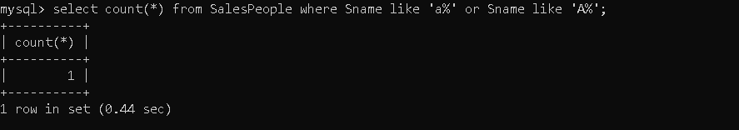

1. Display all the Salesperson whose all orders worth is more than Rs. 2000.

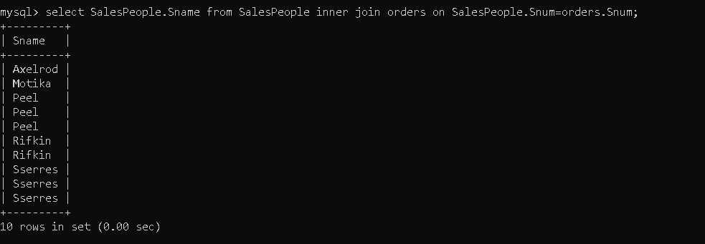

1. Count the number of Salesperson belonging to **Newyork**.

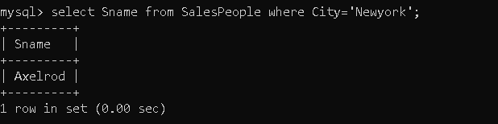

1. Display the number of Salespeople belonging to **London**and belonging to **Paris**.

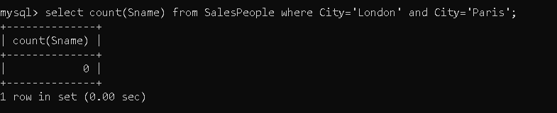

1. Display the number of orders taken by each Salesperson and their date of orders.

